SIMATS ENGINEERING (SAVEETHA SCHOOL OF ENGINEERING)
Department of Computer Science and Engineering
CO2 Assessment Tool 1 – Scenario-Based Requirement Analysis
Course Code: CSA10 | Course Title: Software Engineering
CO Assessed: CO2 | Weightage: 20% | Total Marks: 25
SOFTWARE REQUIREMENT SPECIFICATION (SRS)
Smart Food Supply Chain Traceability and Quality Monitoring System

1. Study and Analysis of the Scenario

1.1 Business Domain
The proposed system operates within the agriculture and food-technology domain, specifically addressing the farm-to-fork food supply chain. It spans agricultural production, food processing, cold-chain logistics, retail distribution, and regulatory quality assurance, integrating IoT sensing, data management, and consumer-facing traceability services.
Food supply chains are inherently multi-party and geographically distributed: a single product batch may pass through a farm, an aggregation centre, a processing plant, one or more distribution hubs, and finally a retail outlet before reaching a consumer. At each handover, information about origin, handling conditions, and quality status is at risk of being lost, delayed, or falsified. The domain therefore combines elements of agri-tech, logistics and cold-chain management, food-safety regulation, and consumer-facing digital services, making it a cross-disciplinary problem that requires careful requirements engineering.

1.2 Business Process Overview
At a high level, the business process begins when a farmer harvests a crop and registers it as a batch in the system. The batch then moves through processing (cleaning, sorting, packaging, or value-addition), during which quality tests may be performed. It is then handed to a distributor for transport, during which environmental conditions such as temperature and humidity are continuously monitored. Upon arrival, the retailer receives and shelves the product, making it available to the end consumer, who can scan a QR code to verify its journey. In parallel, quality inspectors may audit any stage of this process, and if a safety issue is identified, a recall workflow is triggered to notify every stakeholder who has handled the affected batch.

1.3 Stakeholders
Stakeholder | Role in the System
Farmers / Producers | Register harvested produce batches and initial quality data.
Processing Units | Convert raw produce into packaged goods; record processing and lab test results.
Distributors / Logistics Providers | Transport goods; monitor cold-chain conditions during transit.
Retailers | Receive, stock, and sell products; update inventory and shelf information.
Consumers | Verify product origin and quality via QR code scanning; raise complaints.
Quality / Regulatory Inspectors | Conduct compliance checks and upload inspection reports.
System Administrators | Manage user accounts, system configuration, and platform monitoring.
Government / Food Safety Authorities | Access aggregated data for compliance audits and recall enforcement.

1.4 Existing Challenges
- Manual, paper-based record keeping leads to delays and data loss between supply-chain stages.
- Lack of real-time visibility into product location, handling conditions, and custody transfers.
- Delayed detection of contamination or spoilage due to absence of continuous cold-chain monitoring.
- Difficulty in tracing the exact source of a defective or contaminated batch, slowing down recalls.
- Risk of mislabeling, counterfeiting, and fraudulent quality claims due to lack of verifiable records.
- Fragmented systems across stakeholders with no common data-sharing platform.
- Limited accountability when a quality lapse occurs, since it is often unclear which stakeholder in the chain was responsible.
- High wastage of perishable goods because early signs of spoilage are not detected in time to reroute or discount the product.

1.5 System Objectives
- Provide end-to-end, farm-to-fork traceability for every product batch.
- Continuously monitor environmental and quality parameters using IoT sensors.
- Maintain a tamper-evident, auditable record of custody transfers across the supply chain.
- Enable rapid, targeted recall management when a quality or safety issue is detected.
- Allow consumers to verify product authenticity and journey through a simple QR-code scan.
- Reduce food wastage by enabling early, data-driven intervention when quality parameters begin to drift.
- Provide regulators and administrators with aggregated analytics to support policy-making and compliance audits.

1.6 Scenario Narrative
Consider a batch of fresh mangoes harvested by a farmer in a rural district. Under the current manual process, the farmer records the harvest in a notebook, and the batch is transported to a processing unit without any continuous monitoring of temperature or humidity during transit. If the mangoes arrive partially spoiled, there is no way to determine whether the damage occurred during transport, storage, or handling at the farm. Under the proposed system, the farmer instead registers the batch digitally, receiving a unique QR-coded traceability ID. As the batch moves through processing, distribution, and retail, each stakeholder updates the system, and IoT sensors continuously log temperature and humidity. If conditions breach a safe threshold at any point, an alert is raised immediately, allowing corrective action before the entire batch is lost. When the product reaches the retail shelf, a consumer can scan the QR code to see the complete journey, including quality-test results and any inspection reports, ensuring transparency and building trust.

2. Functional and Non-Functional Requirements

2.1 Functional Requirements
ID | Functional Requirement
FR-01 | The system shall allow farmers to register produce batches with details such as crop type, harvest date, and quantity.
FR-02 | The system shall generate a unique traceability ID and QR code for every batch at the point of origin.
FR-03 | The system shall allow processors to record processing steps, dates, and laboratory quality-test results.
FR-04 | The system shall capture real-time IoT sensor data (temperature, humidity, GPS location) during storage and transport.
FR-05 | The system shall automatically trigger alerts when sensor readings breach predefined quality thresholds.
FR-06 | The system shall maintain an immutable, chronological audit trail of custody transfers for each batch.
FR-07 | The system shall allow consumers to scan a product's QR code and view its complete journey and quality history.
FR-08 | The system shall allow quality inspectors to upload inspection reports and flag non-compliant batches.
FR-09 | The system shall generate and dispatch recall notifications to all affected stakeholders when a batch is flagged unsafe.
FR-10 | The system shall provide role-based dashboards for administrators and regulators showing supply-chain analytics.
FR-11 | The system shall enforce role-based access control, restricting actions according to stakeholder type.
FR-12 | The system shall allow searching and filtering of batches by product, date, location, or status.
FR-13 | The system shall expose REST APIs for integration with existing ERP and warehouse-management systems.
FR-14 | The system shall send notifications via SMS, email, or in-app push for critical events.
FR-15 | The system shall allow authorized users to export compliance reports in PDF or CSV format.

2.2 Non-Functional Requirements
Quality Attribute | Requirement Description
Performance | The system shall process and log sensor data with a maximum latency of 2 seconds and support at least 5,000 concurrent transactions.
Security | All data in transit and at rest shall be encrypted (TLS 1.2+/AES-256); access shall require multi-factor authentication for administrators.
Reliability | The system shall achieve 99.9% uptime, with automated failover for critical services.
Usability | The interface shall be simple and multilingual to accommodate farmers and workers with limited technical literacy.
Scalability | The architecture shall support horizontal scaling to accommodate a growing number of stakeholders, batches, and sensor devices.
Maintainability | The system shall be built using modular, loosely-coupled microservices to simplify updates and debugging.
Availability | Core traceability and alerting services shall be available 24/7, including during peak harvest seasons.
Interoperability | The system shall use standard REST/JSON APIs and standard barcode/QR formats for integration with third-party systems.
Data Integrity | Custody and quality records shall be stored in an append-only, hash-chained ledger to prevent unauthorized modification.

3. Actors and Use Cases

3.1 Actors
Actor Type | Actor | Description
Primary | Farmer / Producer | Registers batches and enters initial harvest data.
Primary | Processor | Records processing and quality-test information.
Primary | Distributor | Updates transport details; monitored via IoT sensors.
Primary | Retailer | Receives shipments and manages retail-level inventory.
Primary | Consumer | Scans QR codes to verify product journey and quality.
Primary | Quality Inspector | Conducts inspections and flags non-compliant batches.
Secondary | System Administrator | Manages users, roles, and system configuration.
Secondary | IoT Sensor Devices | Automatically transmit environmental data to the system.
Secondary | ERP / Warehouse System | Exchanges inventory and order data via API integration.

3.2 Use Case Diagram
The diagram below illustrates the primary and secondary actors and their associated use cases within the Smart Food Supply Chain Traceability and Quality Monitoring System.
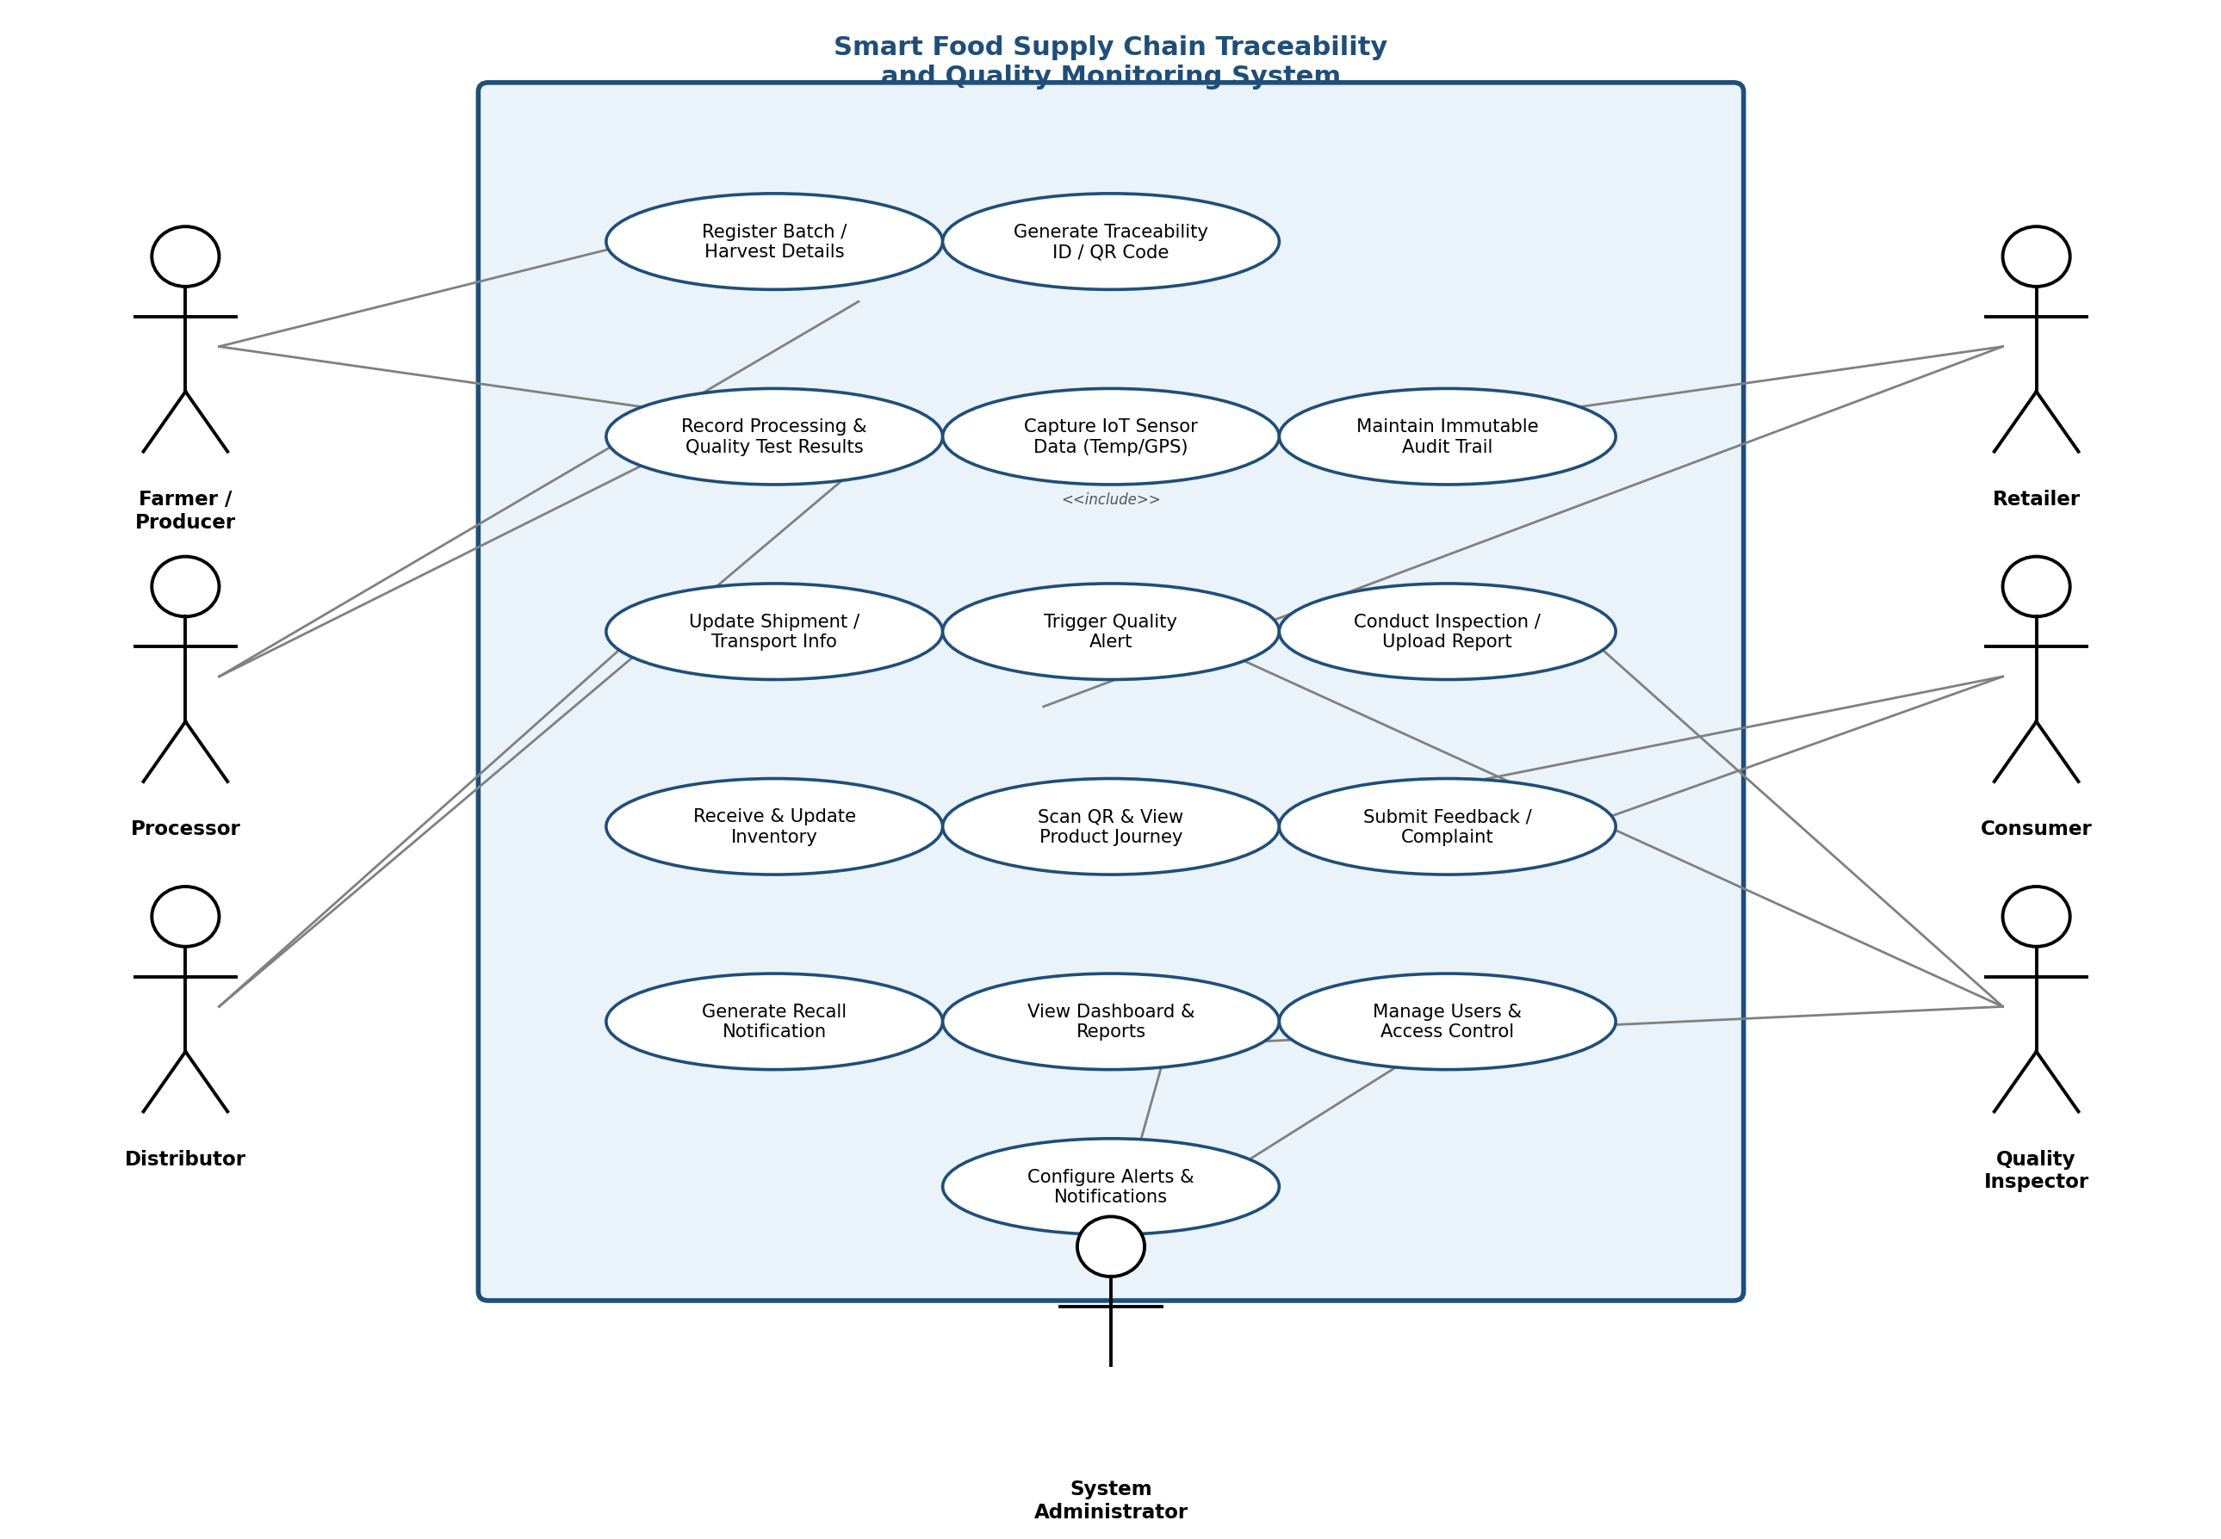

3.3 Major Use Cases by Actor
Actor | Use Cases
Farmer / Producer | Register Batch / Harvest Details  View Batch Status
Processor | Record Processing & Quality Test Results  Generate Traceability ID / QR Code
Distributor | Update Shipment / Transport Info  Monitor Cold-Chain Sensor Data
Retailer | Receive & Update Inventory  Confirm Delivery
Consumer | Scan QR & View Product Journey  Submit Feedback / Complaint
Quality Inspector | Conduct Inspection / Upload Report  Trigger Quality Alert  Generate Recall Notification
System Administrator | Manage Users & Access Control  Configure Alerts & Notifications  View Dashboard & Reports

4. Software Requirement Specification (SRS)

4.1 Introduction
This Software Requirement Specification (SRS) defines the functional and non-functional requirements for the Smart Food Supply Chain Traceability and Quality Monitoring System. The document is intended for use by the development team, project stakeholders, and evaluators to establish a shared understanding of the system's intended behaviour and scope.

4.2 Problem Description
Current food supply chains rely heavily on manual, disconnected record-keeping practices across farmers, processors, distributors, and retailers. This results in poor visibility into product provenance, delayed identification of quality or safety issues, and slow, imprecise recall processes when contamination is detected. The proposed system addresses these gaps by digitizing the entire supply chain journey, from harvest to consumer, using IoT-based monitoring and a shared, tamper-evident traceability ledger.

4.3 Scope of the System
The system will cover the digital registration of produce batches, IoT-based environmental monitoring during storage and transport, quality inspection workflows, consumer-facing traceability verification, and recall management. It will integrate with existing ERP and warehouse-management systems via APIs but will not itself replace core inventory or financial accounting systems. The initial scope targets perishable food categories such as fruits, vegetables, dairy, and meat products.

4.4 Functional Requirements
Refer to Section 2.1 for the complete list of functional requirements (FR-01 to FR-15), covering batch registration, sensor data capture, quality alerting, traceability ledger maintenance, recall management, and reporting.

4.5 Non-Functional Requirements
Refer to Section 2.2 for the complete list of non-functional requirements covering performance, security, reliability, usability, scalability, maintainability, availability, interoperability, and data integrity.

4.6 Use Case Descriptions
Use Case | Actor(s) | Description | Precondition | Postcondition
Register Batch | Farmer | Farmer submits crop type, harvest date, and quantity to create a new batch record. | Farmer is authenticated. | A unique batch ID and QR code are generated.
Generate Traceability ID / QR Code | Processor / System | System automatically generates a unique, scannable traceability ID for a newly registered or processed batch. | Batch registration or processing step is complete. | QR code is printed/attached and linked to the batch record.
Record Processing & Quality Test Results | Processor | Processor logs processing steps performed and uploads laboratory quality-test results for a batch. | Processor is authenticated and batch exists in the system. | Processing history and test results are appended to the batch record.
Capture Sensor Data | IoT Sensor Devices | Sensors periodically transmit temperature, humidity, and GPS data linked to a batch in transit. | Sensor is registered and paired with a batch. | Sensor readings are stored and evaluated against thresholds.
Update Shipment / Transport Info | Distributor | Distributor records carrier details, dispatch time, and destination for a batch in transit. | Batch has been handed over to the distributor. | Shipment record is created and linked to the batch.
Trigger Quality Alert | System | System automatically raises an alert when incoming sensor data breaches a configured safety threshold. | A sensor reading has been received for an active shipment. | Relevant stakeholders are notified in real time.
Receive & Update Inventory | Retailer | Retailer confirms receipt of a shipment and updates retail-level stock records. | Shipment has arrived at the retail location. | Inventory levels are updated and the batch status changes to "In Store".
Scan QR & View Journey | Consumer | Consumer scans the product QR code to view its complete origin, processing, and transport history. | Product carries a valid QR code. | Traceability history is displayed to the consumer.
Submit Feedback / Complaint | Consumer | Consumer submits a quality complaint or feedback linked to a specific batch after purchase. | Consumer has scanned or identified the batch. | Feedback is logged and routed to the relevant stakeholder/administrator.
Conduct Inspection / Upload Report | Quality Inspector | Inspector reviews a batch and uploads a compliance/inspection report. | Inspector is authenticated and assigned to the batch. | Batch status is updated (compliant / flagged).
Generate Recall Notification | System / Quality Inspector | System automatically generates and sends recall alerts when a batch is flagged unsafe. | Batch has been flagged non-compliant. | Affected stakeholders receive recall notifications.
View Dashboard & Reports | System Administrator / Regulator | Authorized users view aggregated analytics on batches, alerts, and compliance across the supply chain. | User holds an administrator or regulator role. | Dashboard renders up-to-date supply-chain analytics.
Manage Users & Access Control | System Administrator | Administrator creates, modifies, or deactivates stakeholder accounts and assigns roles. | Administrator is authenticated. | User account and permission changes take effect immediately.
Configure Alerts & Notifications | System Administrator | Administrator defines or adjusts quality thresholds and notification rules per product category. | Administrator is authenticated. | Updated thresholds apply to subsequent sensor evaluations.

4.7 Data Requirements
The system shall maintain the following core data entities:
Entity | Key Attributes
Batch | Batch ID, Product Type, Harvest Date, Quantity, Origin Location, Current Status
Stakeholder | User ID, Name, Role, Contact Details, Registered Location
Sensor Reading | Reading ID, Batch ID, Sensor Type, Value, Timestamp, GPS Coordinates
Inspection Report | Report ID, Batch ID, Inspector ID, Result, Comments, Date
Shipment | Shipment ID, Batch ID, Origin, Destination, Carrier, Status
Custody Transfer / Ledger Entry | Entry ID, Batch ID, From-Actor, To-Actor, Timestamp, Hash Reference

4.8 External Interface Requirements
Interface Type | Description
User Interfaces | Responsive web dashboard for administrators/regulators; mobile applications for farmers, processors, distributors, retailers, and inspectors; a lightweight consumer-facing scan page.
Hardware Interfaces | IoT temperature/humidity sensors, GPS trackers, RFID/QR scanners and printers at packaging and retail points.
Software Interfaces | REST APIs for integration with ERP and warehouse-management systems; SMS/email gateway for notifications.
Communication Interfaces | HTTPS/REST for client-server communication; MQTT for lightweight IoT sensor data transmission.

4.9 System Features
- Traceability Ledger: An append-only, hash-chained record of every custody transfer and quality event for a batch, ensuring data cannot be altered retroactively.
- Quality Alert Engine: Continuously evaluates incoming IoT sensor data against configurable thresholds and triggers real-time alerts to relevant stakeholders.
- QR-Based Consumer Portal: A public-facing page, accessed by scanning a product's QR code, that displays its complete farm-to-fork journey and quality status.
- Recall Management Module: Automates the identification of affected batches and downstream stakeholders, and dispatches recall notifications within minutes of a flag being raised.

5. System Architecture

5.1 Architectural Approach
The system follows a layered, microservices-based architecture to satisfy the scalability, maintainability, and interoperability requirements identified in Section 2.2. Each core capability — batch registration, quality alerting, ledger maintenance, recall management, and reporting — is implemented as an independently deployable service communicating through a REST API gateway and an asynchronous message bus. This separation allows individual services to be scaled, updated, or replaced without affecting the rest of the system.

5.2 Layered Architecture Diagram
The diagram below presents the system as six logical layers, from field-level IoT hardware at the bottom to stakeholder-facing applications at the top.
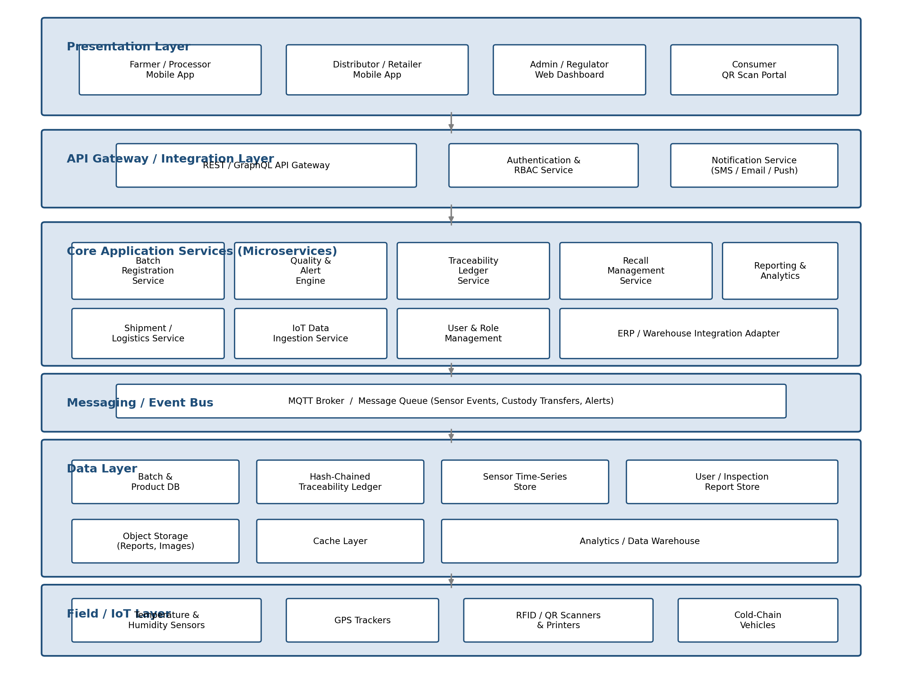

5.3 Layer Descriptions
Layer | Responsibility
Presentation Layer | Role-specific mobile apps and web dashboards through which stakeholders interact with the system.
API Gateway / Integration Layer | Single entry point for all client requests; handles authentication, authorization, and request routing.
Core Application Services | Independently deployable microservices implementing batch registration, quality alerting, ledger, recall, and reporting logic.
Messaging / Event Bus | Asynchronous transport for high-frequency sensor events, custody-transfer events, and alert triggers.
Data Layer | Persistent storage split across relational, time-series, ledger, and object stores according to data access patterns.
Field / IoT Layer | Physical sensors, GPS trackers, and QR/RFID hardware that generate the raw data consumed by the system.

6. Requirement Traceability Matrix
The traceability matrix below maps each functional requirement to the use case(s) that realize it, helping to confirm that no requirement is left unimplemented and that every use case is grounded in a stated requirement.
Requirement ID | Realized By Use Case(s)
FR-01 | Register Batch
FR-02 | Generate Traceability ID / QR Code
FR-03 | Record Processing & Quality Test Results
FR-04 | Capture Sensor Data
FR-05 | Trigger Quality Alert
FR-06 | Capture Sensor Data / Update Shipment (ledger entries)
FR-07 | Scan QR & View Journey
FR-08 | Conduct Inspection / Upload Report
FR-09 | Generate Recall Notification
FR-10 | View Dashboard & Reports
FR-11 | Manage Users & Access Control
FR-12 | View Dashboard & Reports
FR-13 | Update Shipment / Transport Info (ERP integration)
FR-14 | Configure Alerts & Notifications
FR-15 | View Dashboard & Reports (export)

7. Assumptions and Constraints

7.1 Assumptions
- All primary stakeholders have access to a smartphone or tablet with a functioning internet connection.
- IoT sensor devices are properly calibrated and maintained by the stakeholders responsible for them.
- Farmers and field staff will receive basic training on using the mobile application.
- Product batches can be uniquely identified and physically labelled with a QR code at the point of origin.
- Stakeholders will use the system in good faith and enter accurate data at each stage.
- Retailers and distributors already possess, or are willing to procure, basic QR/RFID scanning hardware.
- Network coverage, while intermittent in some rural areas, is sufficient to allow periodic (not necessarily continuous) data synchronization.

7.2 Constraints
Constraint Type | Description
Technical | Limited and intermittent internet connectivity in rural farming areas may affect real-time data synchronization.
Operational | Requires training and change-management effort across a diverse set of stakeholders with varying digital literacy.
Economic | Deployment of IoT sensors and QR infrastructure involves upfront hardware and integration costs.
Legal / Regulatory | The system must comply with applicable food-safety and data-protection regulations (e.g., FSSAI guidelines, data privacy laws).
Time | The project must be delivered within the academic/institutional timeline agreed for this assignment cycle.

8. Requirement Validation — Completeness and Consistency

8.1 Stakeholder Requirement Coverage
Each stakeholder group identified in Section 1.3 is cross-checked against the functional requirements and use cases that serve it, confirming that no stakeholder's needs have been overlooked.
Stakeholder | Addressed By | Status
Farmer / Producer | FR-01, FR-02, UC: Register Batch | Covered
Processor | FR-02, FR-03, UC: Record Processing | Covered
Distributor | FR-04, FR-05, FR-06, UC: Update Shipment | Covered
Retailer | FR-12, FR-13, UC: Receive & Update Inventory | Covered
Consumer | FR-07, UC: Scan QR & View Journey, Submit Feedback | Covered
Quality Inspector | FR-08, FR-09, UC: Conduct Inspection | Covered
System Administrator | FR-10, FR-11, FR-14, FR-15 | Covered
Government / Food Safety Authorities | FR-09, FR-10, FR-15 (via administrator/regulator dashboard) | Covered

8.2 Ambiguity, Redundancy, and Inconsistency Check
- Ambiguity: The term "quality threshold" in FR-05 is clarified by specifying that thresholds are configurable per product category rather than a single fixed value.
- Redundancy: FR-12 (search/filter) and the dashboard feature in FR-10 were reviewed to ensure they serve distinct purposes — filtering individual batches versus aggregate analytics — and are not duplicated.
- Inconsistency: Naming was standardized so that "Traceability ID" and "Batch ID" refer to the same identifier throughout the document, avoiding confusion between requirements.
- Missing Requirements Identified: An explicit requirement for data retention/archival policy and one for consumer complaint handling (FR-14 extension) were added after initial review.
- Overlap Check: The Recall Management Module (FR-09) and the Quality Alert Engine (FR-05) were reviewed together — alerts address in-transit threshold breaches, while recalls address confirmed, post-distribution safety issues — confirming they are complementary rather than duplicated.

8.3 Suggested Improvements
- Introduce automated data-quality checks at batch registration to reduce manual entry errors.
- Define clear service-level agreements (SLAs) for alert response times between stakeholders.
- Add an offline-first mobile data capture mode with sync-on-reconnect for low-connectivity rural areas.
- Extend the requirement traceability matrix (Section 6) to link each FR/NFR to concrete test cases prior to development.
- Introduce periodic third-party audits of the traceability ledger to reinforce stakeholder trust in data integrity.
- Pilot the system with a single product category and a small stakeholder group before a full-scale rollout, to validate assumptions in a real operating environment.

9. Glossary of Terms
Term | Definition
Batch | A distinct, traceable lot of a product sharing a common harvest date, origin, and traceability ID.
Cold Chain | The temperature-controlled supply chain used to preserve the quality of perishable food products.
Traceability Ledger | An append-only, hash-chained record of every custody transfer and quality event for a batch.
IoT (Internet of Things) | Networked physical sensors and devices (temperature, humidity, GPS) that capture and transmit real-world data.
RBAC (Role-Based Access Control) | A security model restricting system actions based on a user's assigned role.
Recall | The coordinated withdrawal of a product batch from the supply chain due to a confirmed safety or quality issue.
MQTT | A lightweight publish-subscribe messaging protocol commonly used for IoT sensor communication.
SRS | Software Requirement Specification — a document formally describing the intended functional and non-functional behaviour of a system.

10. References
- Sommerville, I., Software Engineering, 10th Edition — Requirements Engineering and Software Process Models.
- IEEE Std 830-1998 — IEEE Recommended Practice for Software Requirements Specifications.
- Food Safety and Standards Authority of India (FSSAI) — Food Safety and Standards Regulations, applicable guidelines on traceability.
- GS1 Global Traceability Standard — guidelines for supply-chain identification and QR/barcode standards.
- Course materials and lecture notes, CSA10 — Software Engineering, SIMATS Engineering (Saveetha School of Engineering).

